- Watch the terraform-02 video.
2) Execute all the templates shown in video.
When we do terraform init it will create a directorie .terraform which will consist of providers local & random. Marked in the below picture
.terraform.lock.hcl: It is a back file of .terraform directory.
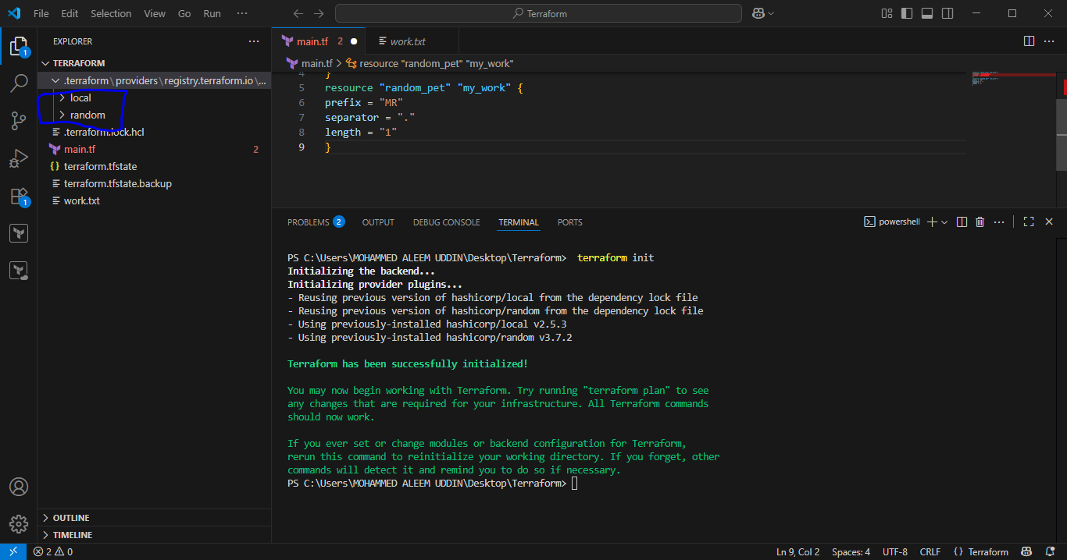
Terraform.tfstate: It consist of complete information or metadata of the resource files
1. Version
2. Text
3. Content
4. File permissions
5. Directory permissions

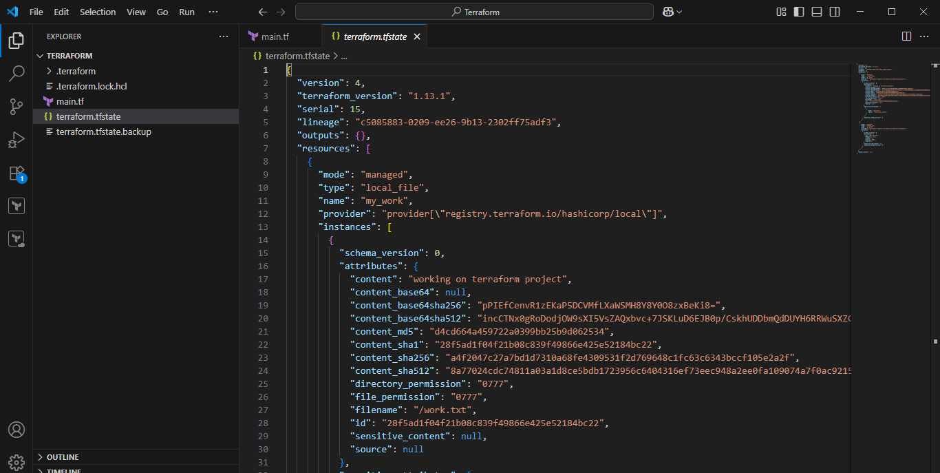
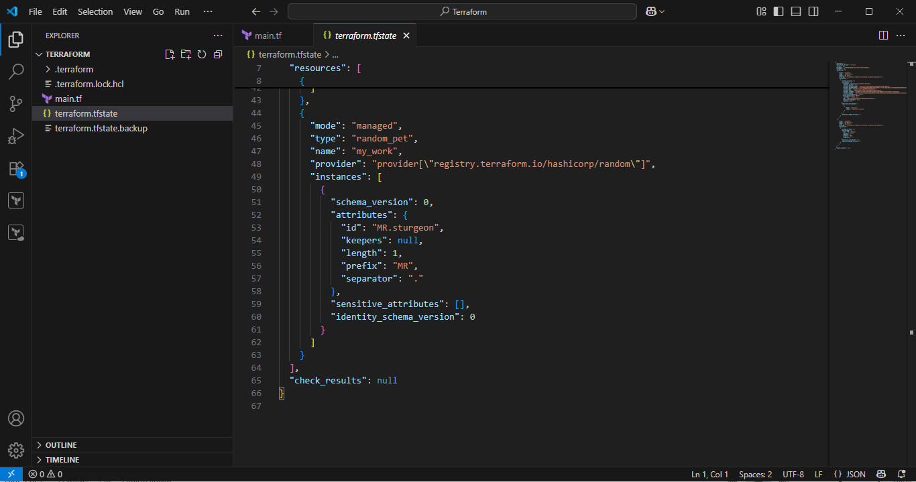
Life Cycle rules:
Create_before_destory: It will create first then destroy file.
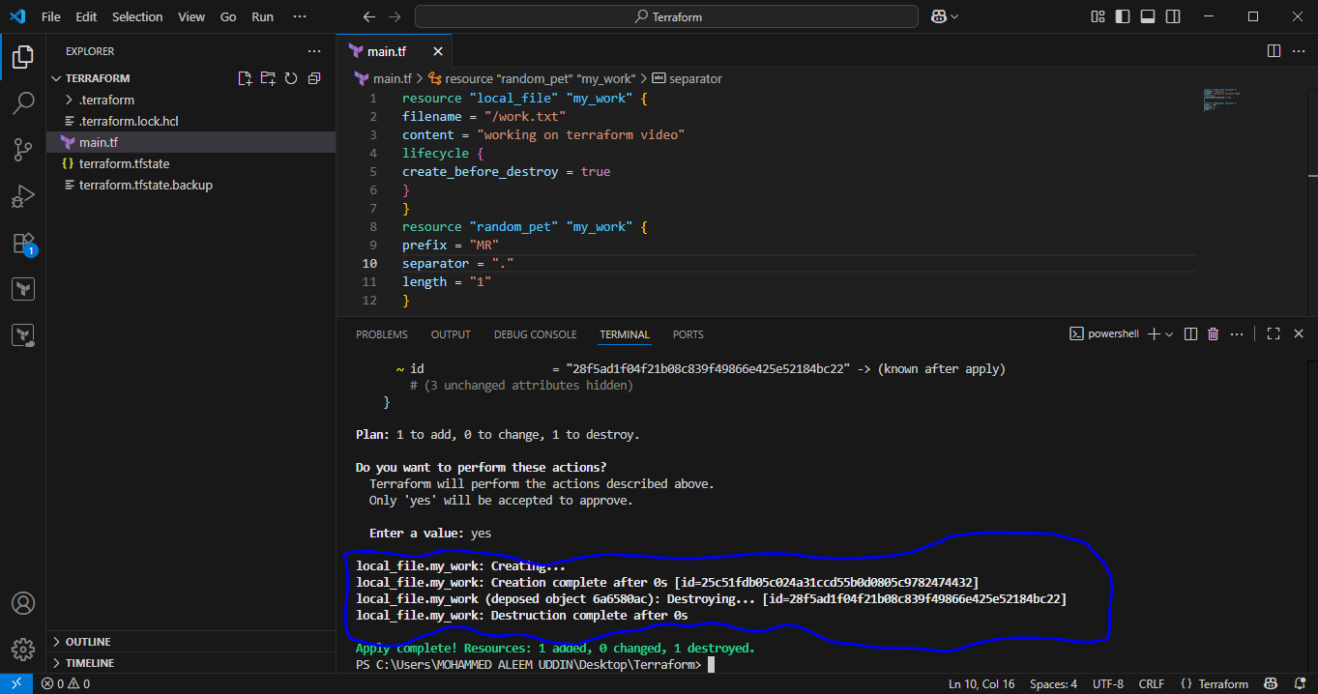
Prevent_destory: It will create the file without destroying old file.
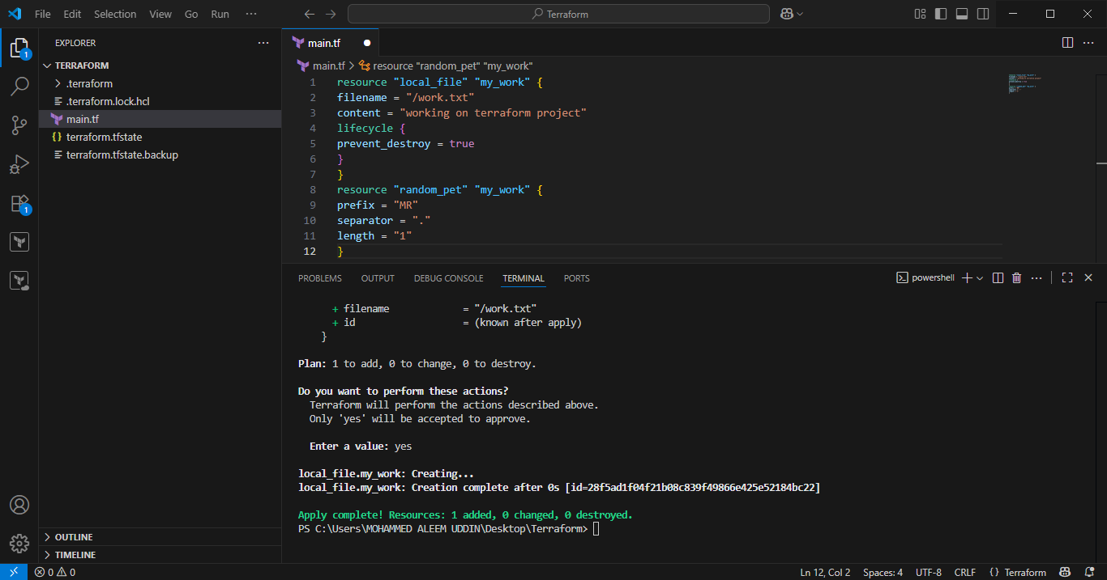
Ignore_changes: It will refresh the file only no changes will be happen.
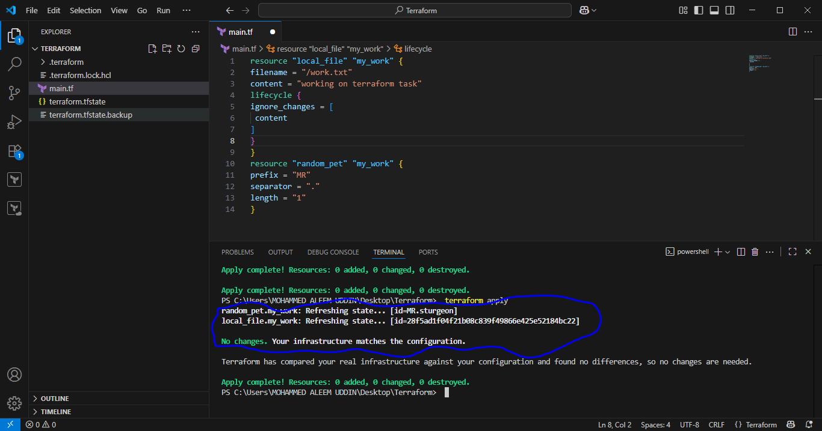

Variable.tf: It will help us to make changes main.tf source file.

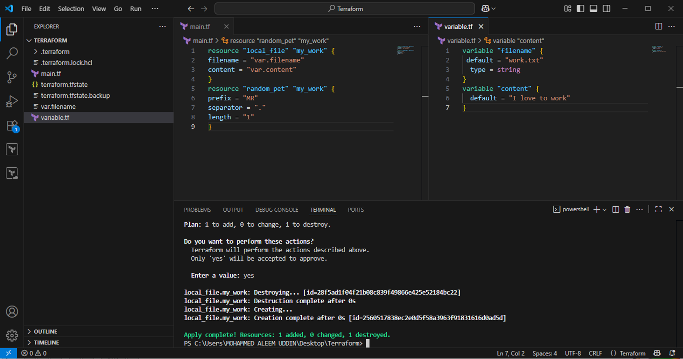
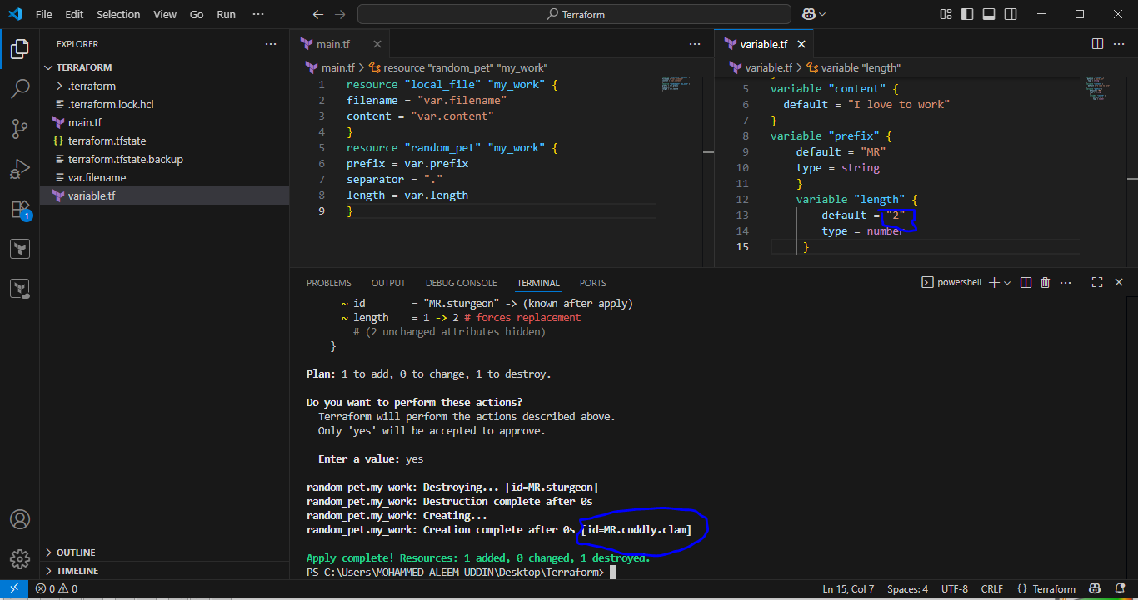
3) Integrate terraform in Jenkins using Terraform plugin.
Jenkins master ec2 need installations below:
sudo yum install -y yum-utils shadow-utils
sudo yum-config-manager --add-repo https://rpm.releases.hashicorp.com/AmazonLinux/hashicorp.repo
sudo yum -y install terraform
1. Install Jenkins and Terraform Plugin:
- Ensure Jenkins is installed and operational.
- Install the "Terraform" plugin through the Jenkins Plugin Manager (Manage Jenkins > Manage Plugins > Available plugins).
2. Configure Terraform Installation in Jenkins:
- Navigate to Manage Jenkins > Global Tool Configuration.
- Scroll to the "Terraform" section and add a new Terraform installation.
- You can choose to install automatically (Jenkins downloads a specific version) or point to an existing Terraform binary if installed manually.
3. Prepare your Terraform Code:
- Create a Git repository containing your Terraform configuration files (e.g., main.tf, variables.tf, outputs.tf).
- Include a Jenkinsfile in the root of your repository to define the Jenkins pipeline stages.
4. Create a Jenkins Pipeline Job:
- In Jenkins, create a new "Pipeline" job.
- Configure the job to use "Pipeline script from SCM" and point it to your Git repository and the Jenkinsfile.
5. Define the Jenkinsfile:
The Jenkinsfile will orchestrate the Terraform workflow. A basic example for applying a Terraform configuration might look like this:
Jenkinsfile:
pipeline {
agent any

environment {
AWS_ACCESS_KEY_ID = credentials('terraform-access')
AWS_SECRET_ACCESS_KEY = credentials('Terraform-secret')
}

stages {
stage('Checkout Code') {
steps {
git url: 'https://github.com/ALEEMUDDIN138/Terraform.git', branch: 'main'
}
}

stage('Terraform Init') {
steps {
sh 'terraform init'
}
}

stage('Terraform Plan') {
steps {
sh '''
terraform plan \
-var "filename=example.txt" \
-var "content=Hello from Jenkins Pipeline"
'''
}
}

stage('Terraform Apply') {
steps {
sh '''
terraform apply -auto-approve \
-var "filename=example.txt" \
-var "content=Hello from Jenkins Pipeline"
'''
}
}
}
}
Main.tf:
resource "local_file" "my_work" {
filename=var.filename
content=var.content
}

Variable.tf:
variable "filename" {
description = "The name of the file to create"
type = string
}
variable "content" {
description = "The content to put inside the file"
type = string
}
- agent any: Specifies that the pipeline can run on any available agent.
- Checkout: Clones your Terraform repository. Replace your-git-credentials-id and your-terraform-repo-url with your specific details.
- Terraform Init: Initializes the Terraform working directory.
- Terraform Plan: Generates an execution plan and saves it to tfplan.
- Terraform Apply: Applies the planned changes. -auto-approve bypasses interactive confirmation.
6. Run the Jenkins Job:
- Save the Jenkins job configuration.
- Manually trigger a build or configure a SCM polling or webhook trigger for automated builds upon code changes.
This setup enables Jenkins to automate the execution of your Terraform templates, facilitating CI/CD for your infrastructure.
Create job and configure as below:
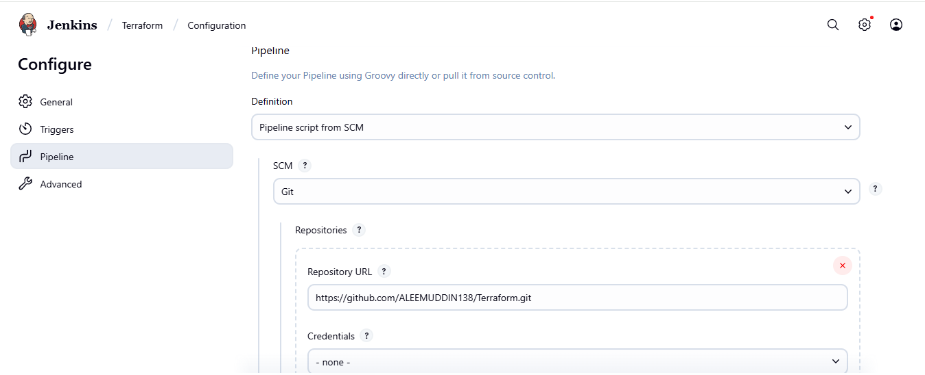
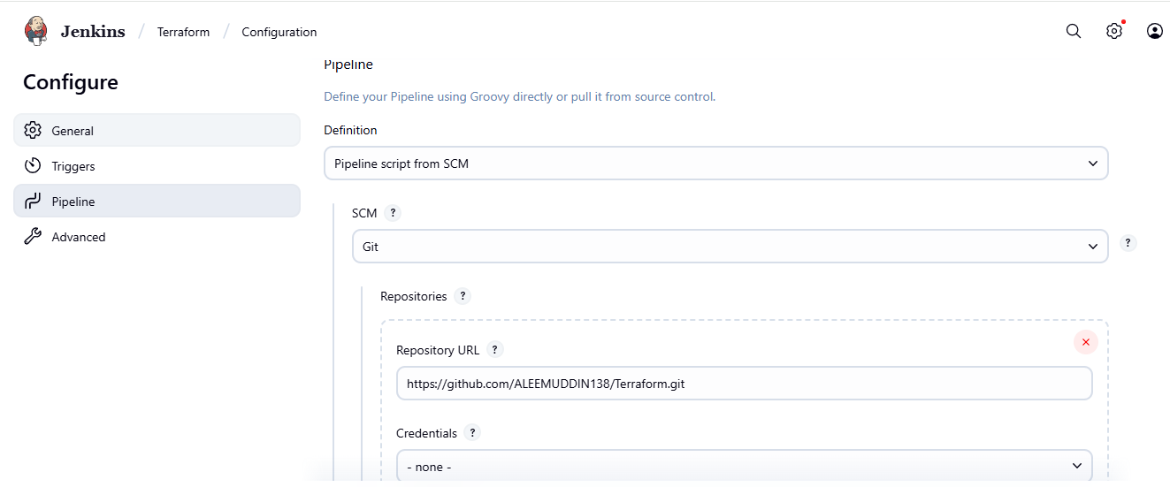Go to plugins and install Terraform
